Requesting contributions for the second edition of

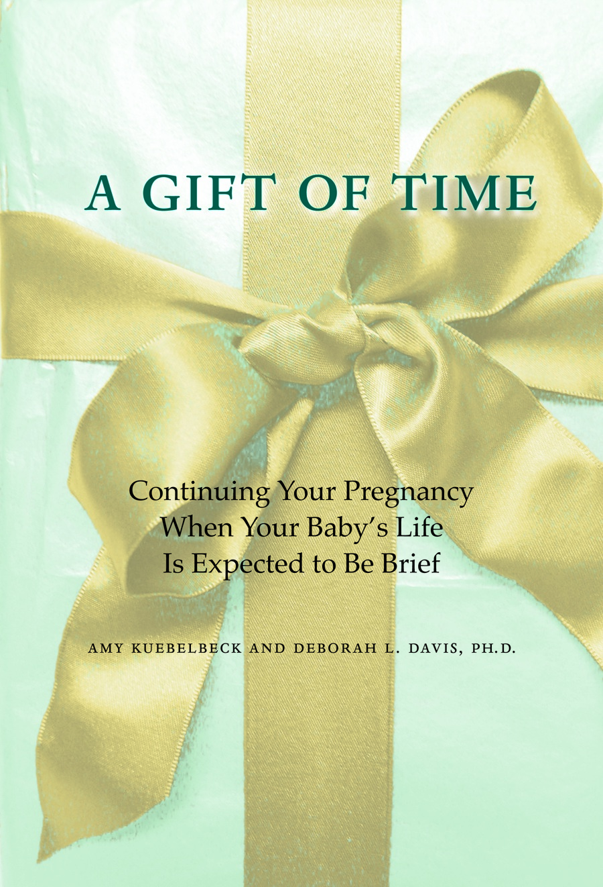

A Gift of Time:
Continuing your pregnancy when your baby’s life is expected to be brief

Amy Kuebelbeck Deborah L. Davis, Ph.D.
Waiting with Gabriel Empty Cradle, Broken Heart

Dear Parents,

Our book A Gift of Time supports parents who continue a pregnancy after receiving the devastating news of their baby’s life-limiting condition. Since it was first published in 2011, A Gift of Time has been adopted as a resource by many hospitals in the U.S. and around the world, and it has been a valued companion for many parents. We are now in the process of revising and updating the book for a second edition. It will continue to accurately, sensitively, and compassionately portray parents’ needs, experiences, and emotions, as well as provide practical suggestions for coping, decision-making, and meaningfully embracing the time before and after a baby’s death. For the bulk of our research for the first edition, we gathered narratives from more than 120 parents who shared their experiences. For this new edition, we want to add voices of parents who have traveled this journey more recently. As before, we will pull incisive quotes from parents’ narratives, so that other parents who read it will find themselves reflected and know that they are not alone.

If you are interested in contributing your words to this project and perhaps being quoted in our writings, we invite you to share your experiences and your feelings about the pregnancy and about parenting your baby.

On the following pages are questions that you can answer directly or use as a guide to tell us about your baby's life and death, the decisions you faced, and your experiences as a mother or father to your baby. Describe the details that are important to you and share whatever you think is relevant. Don’t worry about length or quality — however long or short, polished or rough, whatever you send to us will be gratefully accepted and will inform our writing. Know that we value your contributions and appreciate your desire to help future parents who will travel this road. You will be a beacon of hope to them.

With sympathy and gratitude,

Amy & Debbie

PERMISSIONS for A GIFT OF TIME

I, | (your name here)

grant permission for Deborah L. Davis and Amy Kuebelbeck to quote me in their writings and educational presentations. My quotes may be edited for clarity, and many identifying details, such as surnames, locations, health care provider’s names, brand names, medical specifics, will not be included. In granting this permission, my words still belong to me, and I may use them in any way I choose.

Do we have permission to use your first name? |  | yes |  | no

Your first name, as you want it to appear:

In case there is another parent who shares your name, is there an alternate spelling or nickname we can use for you?

Do we have permission to use your baby’s first name? |  | yes |  | no

Your baby’s name, as you want it to appear:

Do we have permission to use the first names of friends and family members you include? |  | yes |  | no

Your name:

Address:

E-mail:

Phone:

Website, blog, or any social media page for your baby you might wish to share with us:

Details that we’d like to know about you and your baby. If you had twins, triplets, or more, please answer these questions for all of your babies.

Baby girl or baby boy?

Diagnosis

Weeks of pregnancy at diagnosis

Weeks of pregnancy at birth

How long did your baby live?

How much time has passed since your baby’s birth and death?

Optional demographic information:

Race/ethnicity:

Religious affiliation:

Marital status:

Your age at baby’s birth:

QUESTIONS for A GIFT OF TIME

Please return your responses to us by June 1, 2021,
via e-mail at info@perinatalhospice.org.

We are interested in your experiences and emotions during

- your or your partner’s pregnancy,
- your baby’s birth,
- your baby’s life and death, and
- your grieving and adjustment since your baby’s death.

On the next pages, you’ll find open-ended prompts that we hope will help you recount your story. Underneath each prompt are additional questions that you might find meaningful to elaborate on. Again, please feel free to describe whatever details are important to you and share whatever you think is relevant.

Please create as much space as you wish to write your responses.

- Please tell us about the pregnancy with this baby.

Possible topics to address:
- What was your pregnancy like before you received the diagnosis?
- When did you first realize there were problems and/or received a diagnosis?
- What tests or technologies were used to detect and identify your baby’s condition?
- How were you given the news?
- What was that time of receiving the news like for you and your partner?

2. Tell us about the process of making the first major decision, whether or not to continue your pregnancy.

Possible topics to address:
- What options were presented to you by the doctors?
- What were you told (if anything) about support available to help you continue your pregnancy?
- What were you told (if anything) about the option of perinatal hospice & palliative care? What was your initial impression of this option?
- How would you describe the information and support you received from your caregivers?
- Which options did you consider, and what was your thinking about those options?
- Describe your decision-making process, what helped, what didn't help, and how it felt.
- How did you gather information about your baby’s condition and your options? If you used internet research or social media, what was that like for you?
- How did the decision-making process work from the perspective of the relationship between you and your partner?

3. Tell us about the emotional aspects of the rest of your pregnancy, after you decided to continue.

Possible topics to address:
- What emotions did you experience?
- What kind of worries or fears did you have for your baby?
- What kind of worries or fears did you have for yourself or others in your family?
- What kind of hopes did you have for your baby? For yourself? For your family?
- How did you cope? Did you try specific techniques or practices, and how did they work for you?
- What medical situations and decisions did you face during the rest of your pregnancy?
- How was your medical/prenatal care?
- Were there any formal or informal programs for families in your situation?
- Were there any concerns about your own health?
- You and your partner: How did this affect your relationship?
- For fathers and non-pregnant partners: How did you feel during the pregnancy?
- If you had other children, how did you explain this situation to them? How did they respond during the remainder of the pregnancy? Did you seek formal support for them, and if so did that help?
- Do you have thoughts about the spiritual and philosophical aspects of this time?

4. Tell us about the rest of your pregnancy.

Possible topics to address:
- How did you share information about your baby with your friends and family?
- Describe the reactions of your friends and family to your plight—what helped and what hurt?
- What was it like interacting with others (extended family, friends, strangers)?
- Where did you seek support, and were you able to find helpful support?
- How was the medical care for you and your baby during the remainder of the pregnancy?
- Did you find ways to embrace this time and feel close to your baby?
- Did you find ways for the father/nonpregnant partner to feel involved?
- Did you find ways to support each other during this time?
- Did you find ways to make meaningful memories with your baby during this time?
- If you have older children, what was this time like for them?

5. Tell us about your plans and decisions for your baby’s medical care.

Possible topics to address:
- What kinds of medical decisions, if any, did you need to make in advance for your baby?
- How did you research your options and reach decisions?
- How did you feel about making these decisions for your baby?
- What kind of guidance did you receive from your caregivers?
- What kind of emotional support did you have during this process?

6. What preparations did you make for your baby’s birth, and what was this time like for you?

Possible topics to address:
- Did you create a birth plan? If so, which elements were most important to you and why? (If you’d be willing to share your birth plan with us, we’d love to see it.)
- Did your birth plan account for more than one possible scenario, such as live birth, stillbirth, intensive medical care, palliative care etc.?
- What plans did you make for after your baby’s arrival — spiritual rituals, photography, time with siblings/family/friends, etc.?
- Did you make any pre-plans for after-death care— taking your baby home, funeral plans, burial/cremation, etc.?
- What was it like for you as your baby’s expected birth date drew closer?

7. Tell us about your labor and delivery and your baby’s birth.

Possible topics to address:
- What was labor and delivery (or C-section) like for you? How did it compare to what you’d planned for?
- If your baby had already died in utero, what was labor and delivery like for you?
- What was it like when birth was imminent? Experiences with caregivers, emotions during labor, pain relief, unexpected circumstances or changes in care decisions?
- What was it like to meet your baby for the first time? What do you remember seeing?
- If your baby was born alive, what was the time like for you after birth? Did you spend time creating memories and collecting keepsakes?
- If your baby had already died before birth, what was the time like after birth? Did you spend time creating memories and collecting keepsakes?
- If your baby survived to be discharged home, what was that like?
- Were you able to have people important to you spend time with your baby?
- What are your most cherished memories of your baby's life, before and after birth?

8. Tell us about your baby's death.

Possible topics to address:
- What were the circumstances of your baby's death? Who was with your baby? What was that like for you?
- Did you spend time with your baby after death? What did you do during that time, and what was that time like?
- What decisions did you make about your baby’s body? (Autopsy, organ donation, after-death care, transport, etc.)
- Did you relinquish the baby’s body to a hospital caregiver or a funeral director? What was that like for you?
- Did you take your baby’s body home, for a home funeral or for some time together at home before cremation or burial?
- Did you choose to hold a funeral or memorial service?
- What did you choose for your baby’s final resting place? Burial, cremation?
- How did your baby’s dying and death compare to what you'd expected?

9. Tell us about what the time since your baby’s death has been like for you.

Possible topics to address:
- What was your postpartum care and recovery like?
- What has your grief journey been like?
- What emotions have been especially painful for you and how have you coped?
- What situations have been especially painful for you and how have you dealt with them?
- Do you have any regrets? How have you tried to make your peace with them?
- What has the time since your baby’s death been like for your relationship with you and your partner?
- If you have other children, how have they handled the baby’s death?
- How did you handle dealing with the outside world -- letting others know, sharing in social situations, others’ pregnancies and new babies?
- Have you had any subsequent pregnancies?
- What has helped you affirm and honor your baby's life and your love for this child?
- Tell us about any photographs or keepsakes you were able to receive. What do they mean to you?

10. Tell us about any reflections or insights you may have about your journey with your baby.

Possible topics to address:
- If enough time has passed, what has helped you find peace?
- Reflections on knowing the diagnosis before birth, continuing the pregnancy, medical decisions for your baby, perinatal hospice support, facing fears, witnessing death
- Your philosophies about life, death and love
- Spiritual beliefs and struggles — reflections about miracles, life after death
- Long-term reflections on grief and healing
- What meaning have you made or discovered from this experience?
- How would you describe your baby’s place in your family?
- Has your baby had an impact on others?
- How have your beliefs, ideas, and feelings about this experience changed over the course of your pregnancy or your baby’s life?
- Have you noticed any sort of personal growth or transformation?

11. And finally ...

If you could reach back in time and say something to yourself on the day of the diagnosis, what would you say?

Is there anything else you would like to share about your experiences, yourself, or your baby?

We are deeply grateful for your willingness to share your story. We hope you will find sharing your story, and helping light the path of others who will come after you,
to be another way of honoring your baby.

Please return your contributions to us at info@perinatalhospice.org by June 1, 2021.

